# **Warmup**

**Q.) You will be given a number x and you have to compute the value of f(x)**

**F[0]=1,F[1]=1**

**F(x)=F(x-1)+F(x-2) x>=2**

Fibonacci Series-> 1 1 2 3 5 8 13 21….

**Recursive Solution->**

| int f(int x){  if(x==0 || x==1) return 1;  return f(x-1)+f(x-2);  } |
| --- |

//f(5)-> f(4),f(3)-> f(3), f(2);

# **Stack**

Stack is a linear data structure. The insertion and deletion happens only at one end. It follows the property of **“Last In First Out”(LIFO)**

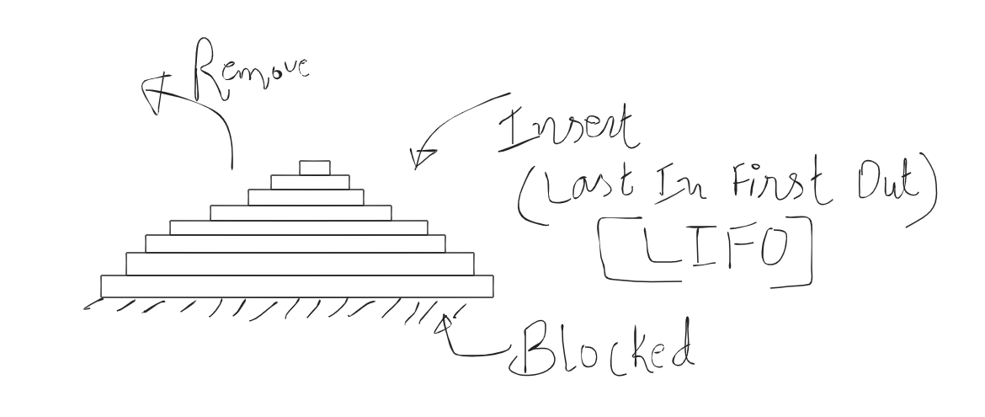

**Syntax for creating a stack**

| stack<data_type> stack_Name; |
| --- |

**Example:**

| stack<char> st;  stack<double> st; |
| --- |

**Functions related to stack: Time Complexity=O(1)**

1. push()-> Insert the last element at the back of your stack.

| st.push(4); |
| --- |

1. pop() -> Remove the last element from the back.

| st.pop(); |
| --- |

1. empty()-> return true is the stack is empty()

| st.empty(); //True/False |
| --- |

1. size() -> return the number of elements presents in the stack.
2. top() -> show the top element

| cout<<st.top(); |
| --- |

# 

# **Queue**

Queue is also a linear data structure in which insertion happens from one end and deletion happens from another end.

It follows the property of **“First In First Out”(FIFO)**

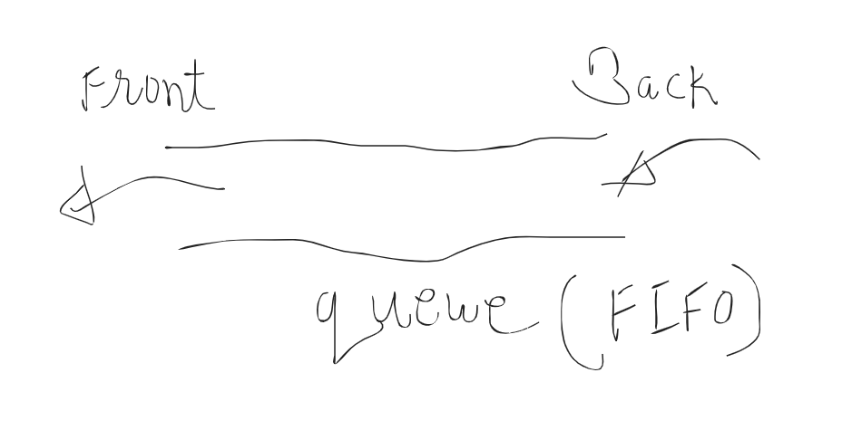

**Syntax for creating a queue**

| queue<data_type> queue_Name; |
| --- |

**Example:**

| queue<char> q; queue<double> q; |
| --- |

**Functions related to queue: Time Complexity=O(1)**

1. push() -> insert the element at the back.

| q.push(4); |
| --- |

1. pop() -> remove the element at the front.

| q.pop(); |
| --- |

1. front() -> show the element present at the front

| cout<<q.front(); |
| --- |

1. empty() -> return true is the queue is empty()

| q.empty(); // returns True or False |
| --- |

1. size()->return the number of elements presents in the queue.

# **Deque (Double ended queue)**

It is also a linear data structure but the main difference with queue is that insertion and deletion happens from both ends.

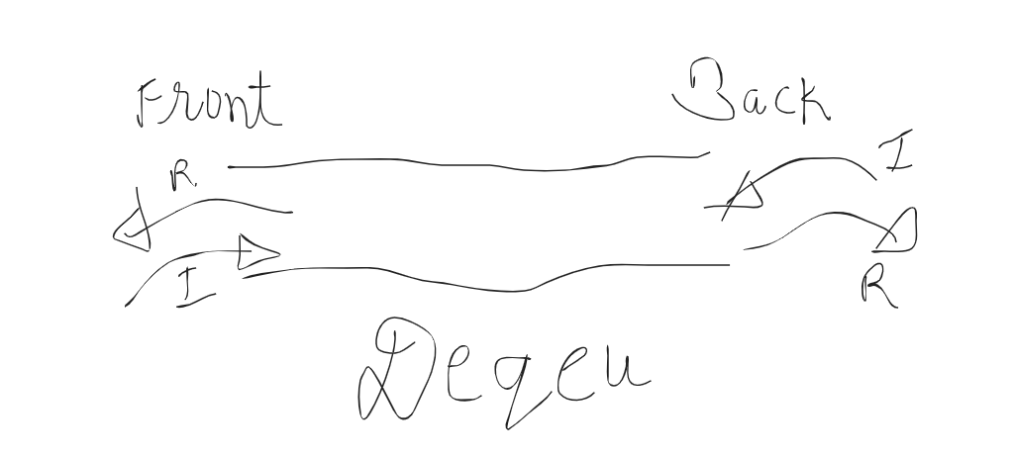

**I-> Insertion**

**R-> Removal**

**Syntax of creating a deque**

| deque<data_type> deque_Name; |
| --- |

**Example**

| deque<char> dq; deque<double> dq; |
| --- |

**Functions related to deque: Time Complexity=O(1)**

1. push_back() -> Insert an element at the back
2. pop_back() -> Remove the last element present at the back
3. push_front() -> Insert an element at the front
4. pop_front() -> Remove the first element present at the front
5. empty() -> return true is the deque is empty()

| dq.empty(); // returns True or False |
| --- |

1. size()->return the number of elements presents in the deque.

**Note**: All these functions for stack, queue and deque have O(1) constant time complexity

# **Some Problems**

## Q.) Balanced Parentheses.

A bracket is considered to be any one of the following characters: (, ), {, }, [, or ].

Two brackets are considered to be a matched pair if the opening bracket (i.e., (, [, or {) occurs to the left of a closing bracket (i.e., ), ], or }) of the exact same type. There are three types of matched pairs of brackets: [], {}, and ()

Return whether the given string is a balanced parentheses or not.

**Link of the problem:** <https://www.hackerrank.com/challenges/balanced-brackets/problem>

**Examples:**

()-> Balanced

[()]-> Balanced

[((]-> not balanced

[(])-> not balanced

{(})-> not balanced

**Definition of Balanced Parentheses**

Empty string is a balanced parentheses.

{},[],() -> balanced parentheses

Lets say a string s -> s is balanced.

{s},(s),[s] -> balanced parentheses.

S and t -> s and t are balanced.

Then s+t -> balanced.

([)]

**Solution Approach:**

ith element -> if it is (,[,{ -> push in the stack

-> if it is closing bracket ] -> [ , )->(, }-> {

( it should match with the top element in stack)

[()[]]

i=0 -> s[i]= [ -> push in stack

Sol:

| string s; // [[  cin>>s;  stack<char> st;  bool balanced=true;  for(int i=0;i<s.length();i++){  if(s[i]=='('||s[i]=='{'||s[i]=='['){  st.push(s[i]);  continue;  }  // a closing bracket encountered....pop one element from the stack  if(!st.empty()){  char c = st.top();  st.pop();  if((s[i]==')'&&c=='(')||(s[i]=='}'&&c=='{')||(s[i]==']'&&c=='[')){  // match of s[i] is found  }else{  // c and s[i] are not matching  balanced=false;  break;  }  }else{  balanced=false;  break;  }  }  if(!st.empty()){  balanced=false;  }  if(balanced){  cout<<"Balanced";  }else{  cout<<"Not balanced";  } |
| --- |
|  |
|  |

**Q: Next Greater Element**

<https://www.codechef.com/problems/DC206>

4,6,5

4,5,6

4,5,7,6

Maintain stack of possible answers

| int a[n]; stack<int> s;     for(int i=n-1;i>=0;i--){  while(!s.empty()&&a[i]>=s.top()){  s.pop();  }  if(!s.empty()){  ans[i]=s.top();  else  ans[i]=-1;  s.push(a[i]); } |
| --- |

**HW:**  
Try to write code for finding "previous smaller element" for each element.

## Practice Problems on Stack, Queue, Deque

1. <https://www.hackerrank.com/challenges/deque-stl/problem>

2. <https://www.spoj.com/problems/STPAR/>

3. <https://www.hackerrank.com/challenges/largest-rectangle/problem>

4. <https://www.hackerrank.com/challenges/queries-with-fixed-length/problem>

5. <https://codeforces.com/contest/1373/problem/B>

6. <https://www.spoj.com/problems/JNEXT/>

7. <https://codeforces.com/contest/1374/problem/C>

8. <https://codeforces.com/contest/1313/problem/C2>